Lab 4: Cache Simulator Report

0511097 黃柏豪 0516329 黃昱彰

1. Basic Problems:
2. **Verilog:**

We use .v codes of lab 3 to implement the whole CPU.

* **Changes:** 
  + **In “Instruction_Memory.v”:** Change the size of instruction_file from [0:31] to [0:64], and read input data from lab4_test_data.txt.
  + **In “TestBench.v”:** Change the whole testbench.v code into the testbench.v code that in supplied files.
* **Outcome:** 
  + After simulating the CPU, it writes ICACHE data and DCACHE data into correspond .txt file.

1. **cpp codes:**

**direct_mapped_cache.cpp**

* **In function “simulate”:** We add two double type number hit and total to calculate the hits when access data. Therefore, we can know the hit rate and miss rate(1-hit_rate)
* If the cache hit, we add 1 to variable “hit”.

And we add 1 to variable “total” when each time read the input data.

* hit rate = ( hit / total )*100;
* miss rate = (( total – hit ) / total ) *100;
* **In main function:** We use two for loop to run the call function of simulate.
* int i, j;

for(i = 1 ; i < 5 ; i++){

for(j = 0 ; j < 5 ; j++)

simulate(pow(2, i*2) * K, pow(2, j+4));

cout << endl;

}

Because it has to run cache_size in 4K, 16K, 64K, 256K

* They are all 2 to the power of i*2
* 2^(1*2) K, 2^(2*2) K, 2^(3*2) K, 2^(4*2) K

And the block_size are 16 B, 32 B, 64 B, 128 B, 256 B

* They are all 2 to the power of j+4
* 2^(0+4) B, 2^(1+4) B, 2^(2+4) B, 2^(3+4) B, 2^(4+4) B

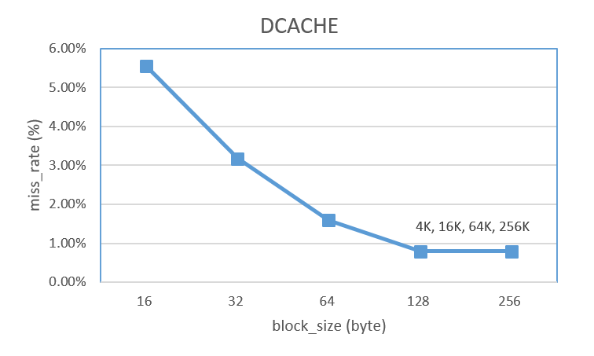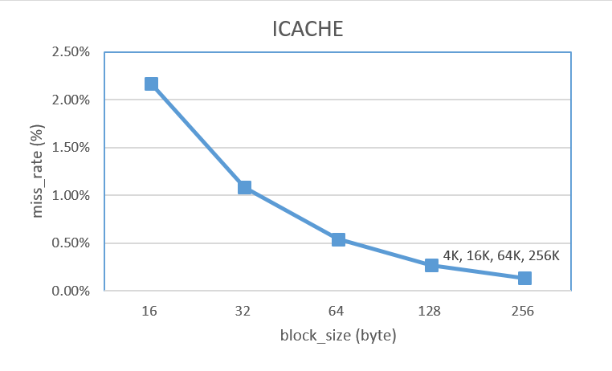

Because when we increase the block_size, we can have more data in the block, it will increase the hit rate and decrease the miss rate. However, when the block_size is larger and larger, the total blocks in a constant size’s cache will become lesser, it will lead to the capacity miss and increase the miss rate.

But we can’t see the raise of the miss rate when the block_size is larger, we guess that it may reach the limit of the miss rate, so we can’t have higher miss rate.

1. Advance problem:
2. **Direct_mapped_cache_LRU.cpp**

* **In struct cache_content:** We use two dimensional vector construct the table.
* **In function “simulate”:** We need to add one more parameter when calling the function which is “ways”, so that we can know how many ways does it have now.

If it is in the cache, increase “hit”, and move it to the first place of cache, which means it is recently used.

If it is not in cache, insert it in to cache, and remove the LRU data in cache.

* **In main function:** We use two for loop to run the call function of simulate.
* int i, j;

for(i = 0 ; i < 6 ; i++){

for(j = 0 ; j < 4 ; j++)

simulate(pow(2, j), pow(2, i) * K, 64);

cout << endl;

}

Because it has to run 1-way, 2-way, 4-way, 8-way

* They are all 2 to the power of j
* 2^0-way, 2^1-way, 2^2-way, 2^3-way

And cache_size are in 1K, 2K, 4K, 8K, 16K, 32K

* They are all 2 to the power of i
* 2^0 K, 2^1 K, 2^2 K, 2^3 K, 2^4 K, 2^5 K

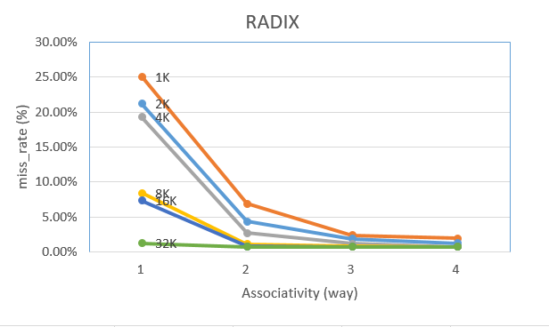

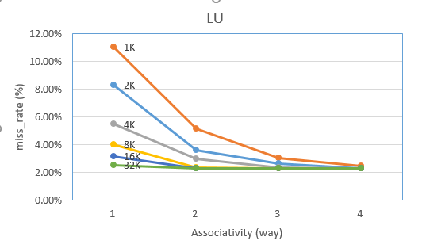

When we have more ways in same cache size, it will have higher associativity and we can have more data in a set to decrease the conflict miss and decrease the miss rate.

Also, we will have less total of set when we have more associativity in a constant size of cache, then it will cause more competition and lead to capacity miss, eventually increase the miss rate.

※If you run the code, it will automatically print out its cache line, cache_size, block_size, miss_rate, and n-way associative.

Problem encounter:

1. We don’t know how to use an array to store the table.

* Sol: We use the two dimensional vector to store the table instead of array.

1. Why the lines in the first problem is the same one?

* Not figure out the answer.
* Discussing with professor and TAs.